**User guide for the Office Français de la Biodiversité**

*Author: Marie Joigneau (trainee supervised by Olivier Gimenez)*

Below is a user guide to apply Artificial Intelligence for lynx identification with an already annotated database.

**The best model requires images of size 260 x 260.**

**The threshold is 0.53.**

**Step 1: Prepare the pictures**

This step consists of preparing the images so that it can be conform to the model and be relevant.

**Option 1: The images are already centered on the lynx and have the size requested by the model.**

Create an OFB file. Create a dataset_ready subfile as below.

Put your ready images in the subfile named *dataset_ready*. Images should be categorized as below. All the images of the same individual are gathered in a folder of this individual. The images to be predicted are in the *0new* folder.

**Option 2: The images are already centered on the lynx but have different sizes than the one requested for the model.**

**Setting up images**

Create an OFB file. Create a *dataset_raw* subfile as below.

Put your images in the subfile named *dataset_raw*. Images should be categorized as below. All the images of the same individual are gathered in a folder of this individual. The images to be predicted are in the *0new* folder.

**Code Usage**

Open the *1_Pre-processing_OFB_resize-only.py* file with a Python utility like Spyder.

Run the code.

You will be asked two questions in the console (see console example below).

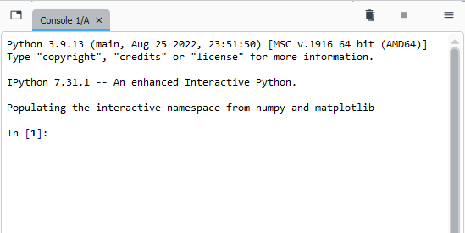

1st question: *Write here the size you want / Ecrivez ici la taille que vous désirez.*

You answer 260 for example if the model requires images of size 260 x 260.

2nd question: *Write here the directory of the OFB folder (end by '/OFB') / Ecrivez ici le chemin d’acces du dossier OFB (fini par /OFB)*.

You answer for example D:/my_code/OFB.

The results are in a new dataset_ready folder.

Your images are ready.

**Option 3: The images are not centered on the lynx and have different sizes than requested for the model.**

**Install Megadetector**

On<https://github.com/microsoft/CameraTraps/blob/main/megadetector.md>, download the model Megadetector mV5a. The file, once downloaded, is called md_v5a.0.0.pt.

Import the utilities to finish installing Megadetector (see below) in your cmd (command prompt).

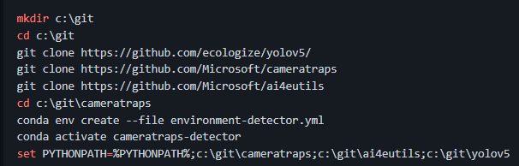

**Setting up images**

Create an OFB file. Create a *dataset_raw* subfile as below.

Put your images in the subfile named *dataset_raw*. Images should be categorized as below. All the images of the same individual are gathered in a folder of this individual. The images to be predicted are in the *0new* folder.

**Obtain a Megadetector file**

For each obtaining of a Megadetector file, you must write on your Anaconda terminal, the following 3 lines:

To use run_detector.py on Windows, when you open a new Anaconda prompt, don't forget to do this:

cd c:\git\CameraTraps

conda activate cameratraps-detector

set PYTHONPATH=%PYTHONPATH%;c:\git\cameratraps;c:\git\ai4eutils;c:\git\yolov5

Then you type in the terminal:

python detection\run_detector_batch.py"c:\megadetector\md_v5a.0.0.pt" "c:\some_image_folder" "c:\megadetector\test_output.json"--output_relative_filenames --recursive --checkpoint_frequency 10000

c:\megadetector\md_v5a.0.0.pt: Megadetector model path (must end with "OFB/md_v5a.0.0.pt")

c:\some_image_folder: access path of the folder containing your images (/!\ you must put an access path ending in “…/OFB/dataset_raw”, given that your images are in this folder).

c:\megadetector\test_output.json: Megadetector result path (must end with "OFB/*megadetector_results.json*")

If you haven't already, rename the Megadetector result file megadetector_results.json and put it in the */OFB* folder.

**Code Usage**

Open the *1_Pre-processing_OFB_crop-resize.py* file with a Python utility like Spyder.

Run the code.

You will be asked several questions in the console (see console example below).

1st question: W*rite here the size you want / Ecrivez ici la taille que vous désirez.*

You answer 260 for example if the model requires images of size 260 x 260.

2nd question: *Write here the directory of the OFB folder (end by '/OFB') / Ecrivez ici le chemin d’acces du dossier OFB (fini par /OFB)*.

You answer for example *D:/my_code/OFB*.

3rd question: Do you want to filter automatically? (yes/no) / voulez-vous filtrer automatiquement? (yes/no)

If you want the code to automatically the most likely location of the individual in the photo, you write yes. Otherwise write no.

If you've chosen the manual side, you'll be asked to write a letter when you're ready (Do you want to filter automatically? (yes/no) / voulez-vous filtrer automatiquement? (yes/no).

You'll have all the picture proposals cropped in the /OFB/bbox_pb folder. You'll for example images idx10_1376_OFB_OCELLES_2020-03-20_Fournet-Luisans_21 and idx11_1376_OFB_OCELLES_2020-03-20_Fournet-Luisans_21 in the /OFB/bbox_pb folder.

And you'll have to write the index of the proposals you don't want to keep (below, if you want to keep the 1st image, write 65.

When you finish, delete the folder */OFB/bbox_pb*.

The results are in a new dataset_ready folder.

Your images are ready.

**Step 2: Launch any model**

Due to a problem of non-recognition of the loss function of the model, you must launch a model with this loss function to be able to carry out the next step.

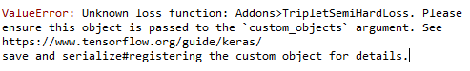

Open the *2_Model-construction_OFB.py* file with a Python utility like Spyder.

Run the code.

A question will be asked in the console (see console example below).

Question: Write here the directory of the OFB folder (end by '/OFB')

You answer for example D:/my_code/OFB.

**Step 3: Run the model and watch the results**

**Option 1: You want to filter your dataset by dates/locations for prediction**

**Setting up metadata**

Put your metadata in the form of a csv named lynx_metadata.csv. It should look like the example below with the lynx's identifier (lynx_ID), the places where it was identified (place), the dates it was identified (date) and the names of the different images (picture) .

Put the metadata in the /OFB folder.

**Code Usage**

Open the *5_Model-prediction-already-dataset_manuel_OFB.py* file with a Python utility like Spyder.

Run the code.

You will be asked several questions in the console (see console example below).

1st question: Write here the treshold / Ecrivez le seuil

You meet the given threshold.

2nd question: *Write here the directory of the OFB folder (end by '/OFB') / Ecrivez ici le chemin d’acces du dossier OFB (fini par /OFB)*.

You answer for example *D:/my_code/OFB*.

3rd question: Do you want to filter individuals? (yes/no) / Voulez-vous filtrer les individus (écrire yes/no).

You answer yes.

4th question: Choose the year you want (none if not) / Choisissez l’année à filtrer (écrivez none sinon)

You answer for example 2006.

5th question: Choose the place you want (none if not) / Choisissez la date pour filtrer (écrivez none sinon)

For example, you answer A.

The results are in the form of a csv named results_k-voisins_manuel in /OFB.

**Option 2: You don't want to filter your dataset**

Open the *5_Model-prediction-already-dataset_manuel_OFB.py* file with a Python utility like Spyder.

Run the code.

You will be asked two questions in the console (see console example below).

1st question: Write here the treshold / Ecrivez le seuil

You meet the given threshold.

2nd question: *Write here the directory of the OFB folder (end by '/OFB') / Ecrivez ici le chemin d’acces du dossier OFB (fini par /OFB)*.

You answer for example *D:/my_code/OFB*.

3rd question: Do you want to filter individuals? (yes/no) / Voulez-vous filtrer les individus (écrire yes/no).

You answer with no.

The results are in the form of a csv named results_k-voisins_manuel in */OFB*.